**Pizza Sales SQL Queries**

1. **KPI’s**

**1.Total Revenue:**

select sum(total_price) as total_revenue from pizza_sales where month(order_date)=1;

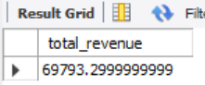

**2. Average Order Value**

select sum(total_price) / count(distinct order_id) as avg_order_value from pizza_sales where month(order_date)=1;

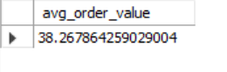

**3.Total Pizzas Sold**

select sum(quantity) as total_pizza_sold from pizza_sales where month(order_date)=1;

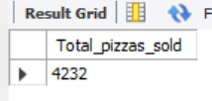

**4.Total Orders**

select count(distinct order_id) as total_orders from pizza_sales where month(order_date)=1;

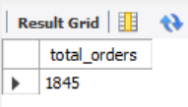

**5. Average Pizzas Per Order**

SELECT CAST( CAST(SUM(quantity) AS DECIMAL(10,2)) /

CAST(COUNT(DISTINCT order_id) AS DECIMAL(10,2))

AS DECIMAL(10,2)) AS avg_pizzas_per_order FROM pizza_sales where month(order_date)=1 ;

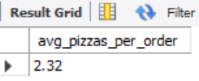

**6. Daily Trend for Total Orders**

SELECT DAYNAME(order_date) AS order_day, COUNT(DISTINCT order_id) AS total_orders FROM pizza_sales WHERE order_date IS NOT NULL and month(order_date)=1 GROUP BY DAYOFWEEK(order_date), DAYNAME(order_date) ORDER BY

DAYOFWEEK(order_date);

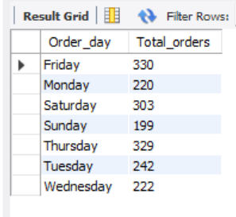

**7. Hourly Trend for Orders**

SELECT HOUR(order_time) AS order_hours, COUNT(DISTINCT order_id) AS total_orders FROM pizza_sales WHERE order_time IS NOT NULL and month(order_date)=1

GROUP BY HOUR(order_time) ORDER BY HOUR(order_time);

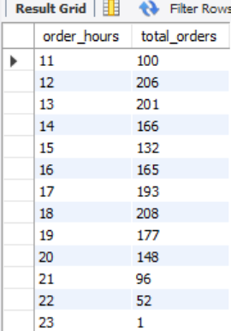

**8. % of Sales by Pizza Category**

SELECT pizza_category, SUM(total_price) AS Total_sales, CAST(SUM(total_price) * 100 / ( SELECT SUM(total_price) FROM pizza_sales ) AS DECIMAL(10,2)) As PCT FROM pizza_sales GROUP BY pizza_category;

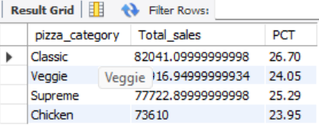

**9. % of Sales Pizza Size**

select pizza_size,sum(total_price) as total_sales, cast(sum(total_price)*100

/(select sum(total_price) from pizza_sales) as decimal(10,2)) as PCT from pizza_sales group by pizza_size order by PCT desc;

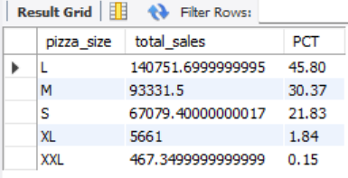

**10. Total pizzas sold by Pizza Category**

select pizza_category,sum(quantity) as total_pizzas_sold from pizza_sales where month(order_date=1 group by pizza_category;

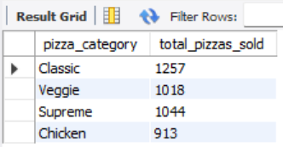

**11. Top 5 Best Sellers by Total Pizzas Sold**

select pizza_name,sum(quantity) as total_pizzas_sold from pizza_sales where month(order_date)=1 group by pizza_name order by sum(quantity) desc limit 5;

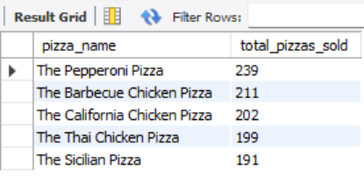

**12. Bottom 5 Best Sellers by Total Pizzas Sold**

select pizza_name, sum(quantity) as total_pizzas_sold from pizza_Sales where month(order_date)=1

group by pizza_name order by sum(quantity) limit 5;

